-- 1. List the department managers who are controlling more than 2 projects.

**SELECT** Fname, Lname

**FROM** EMPLOYEE

**WHERE** Ssn

**IN** (**SELECT** Mgr_ssn

**FROM** DEPARTMENT

**WHERE** Dnumber

**IN** (**SELECT** Dnum

**FROM** PROJECT

**GROUP** **BY** Dnum

**HAVING** **COUNT**(Dnum) > 2));

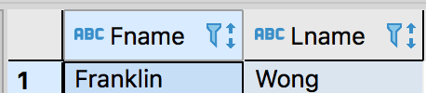

-- 2. Retrieve the names of the departments that only located in ‘Houston’.

**SELECT** Dname

**FROM** DEPARTMENT

**WHERE** Dnumber

**IN** (**SELECT** Dnumber

**FROM** DEPT_LOCATIONS

**WHERE** Dlocation = "Houston")

**AND**

**NOT** Dname =

(**SELECT** Dname

**FROM** DEPARTMENT

**WHERE** Dnumber

**IN** (**SELECT** Dnumber

**FROM** DEPT_LOCATIONS

**WHERE** Dnumber

**GROUP** **BY** Dnumber

**HAVING** **COUNT**(Dnumber) > 1));

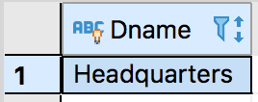

-- 3. List the names of employees all of whose dependents were born before 1960.

**SELECT** Fname, Lname, Dependent_name

**FROM** EMPLOYEE

**LEFT** **JOIN** DEPENDENT

**ON** Ssn = Essn

**WHERE** Essn **IN** (**SELECT** Essn **FROM** DEPENDENT **WHERE** **YEAR**(DEPENDENT.Bdate) < 1960)

**AND** **NOT** Essn **IN** (**SELECT** Essn **FROM** DEPENDENT **WHERE** **YEAR**(DEPENDENT.Bdate) > 1960);

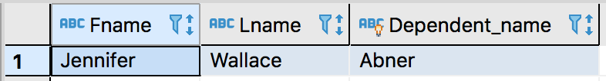

-- 4. List the names of departments managed by the direct subordinate of the manager of ‘Headquarters’ department.

**SELECT** Dname

**FROM** DEPARTMENT

**WHERE** Mgr_ssn

**IN**(**SELECT** Ssn

**FROM** EMPLOYEE

**WHERE** Ssn

**IN**(**SELECT** Ssn

**FROM** EMPLOYEE

**WHERE** Super_ssn

**In**(**SELECT** Mgr_ssn

**FROM** DEPARTMENT

**WHERE** Dname = "Headquarters")));

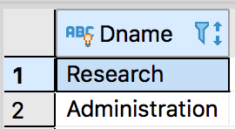

-- 5. Retrieve the average salary of male employees who work totally no less than 50 hours on projects.

**SELECT** **AVG**(Salary)

**FROM** EMPLOYEE

**WHERE** Ssn

**IN**(**SELECT** Essn

**FROM** WORKS_ON

**GROUP** **BY** Essn

**HAVING** **SUM**(Hours) >= 50);

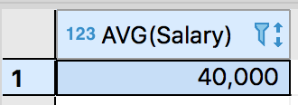

-- 6. Find the names of projects that all direct subordinates of James Borg work for.

**SELECT** Pname

**FROM** PROJECT

**WHERE** Pnumber

**IN**(**SELECT** Pno **FROM** WORKS_ON A

**WHERE** Essn

**IN**(**SELECT** Ssn **FROM** EMPLOYEE

**WHERE** Super_ssn

**IN**(**SELECT** Ssn **FROM** EMPLOYEE **WHERE** Fname = "James" **AND** Lname = "Borg"))

**GROUP** **BY** Pno

**HAVING** **COUNT**(Pno) = (**SELECT** **COUNT**(Ssn) **FROM** EMPLOYEE **WHERE** Super_ssn

**IN**(**SELECT** Ssn **FROM** EMPLOYEE **WHERE** Fname = "James" **AND** Lname = "Borg")));

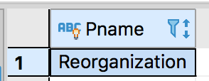

-- 7. Show the name of employee who and whose supervisor are in different departments.

**SELECT** emp.Fname, emp.Super_ssn, emp.Dno

**FROM** EMPLOYEE **as** emp

**LEFT** **JOIN** EMPLOYEE **as** sup

**ON** emp.Super_ssn = sup.Ssn

**WHERE** emp.Dno != sup.Dno;

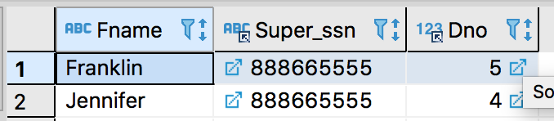

-- 8. Find the name of employee who only has spouse as the dependent.

**SELECT** Fname, Lname

**FROM** EMPLOYEE **as** emp

**WHERE** emp.Ssn

**IN** (**SELECT** dep.Essn

**FROM** DEPENDENT **as** dep

**WHERE** dep.Relationship = 'Spouse')

**AND** emp.Ssn

**IN** (**SELECT** dep2.Essn

**FROM** DEPENDENT **as** dep2

**GROUP** **BY** dep2.Essn

**HAVING** **Count**(dep2.Essn) = 1);

